Chapter 1 MIT App Inventor 2 – Guess the number Game (Part 1)

Key Words
Guess猜測 | Range 範圍 | User Interface 用戶介面
Component 元件 | Properties 屬性 | Title 標題
Block程式塊 | Condition條件 | Export 匯出

1.1 Guess the number game
- In this game, players enter an integer to guess the correct answer.
- The game will tell the players a smaller range of the numbers if the answer is not correct.
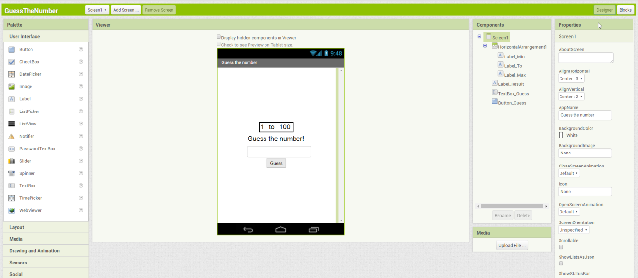

1.2 Start Programming an App in MIT App Inventor 2
- Search "ai2" in Google.

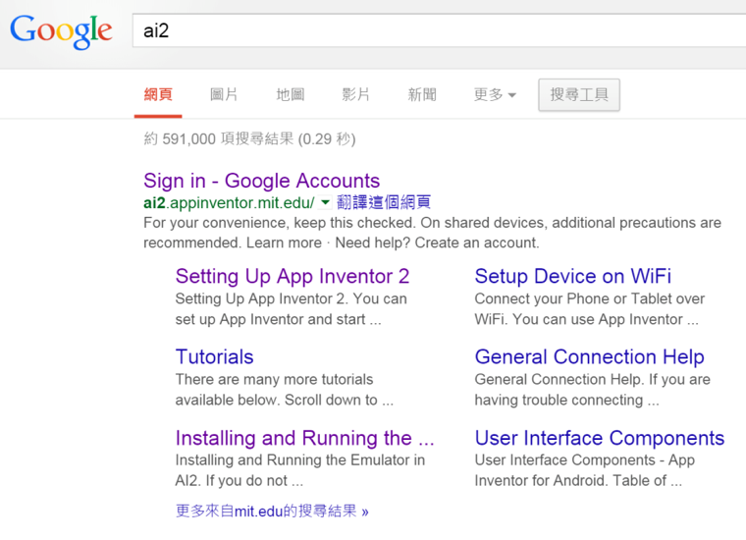

- Step 2: Openhttp://ai2.appinventor.mit.edu/and Sign in with your School gmail Account.
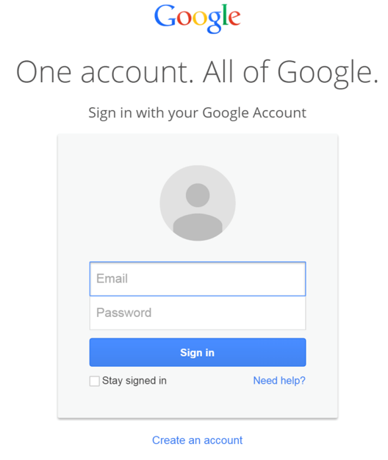

- Choose "Start new project" in the menu "Projects".
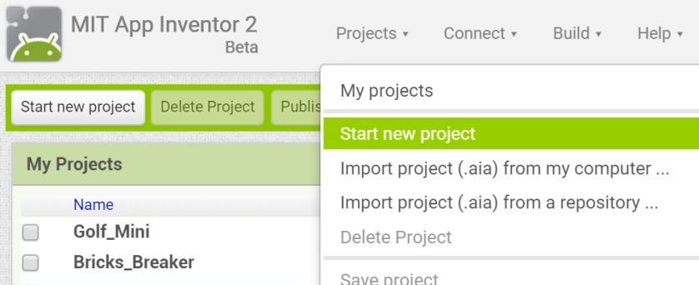

- Enter “GuessTheNumber”. (No Space for names)
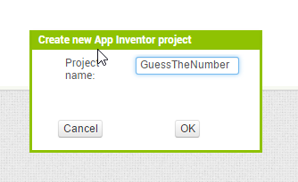

- Start designing the User Interface.
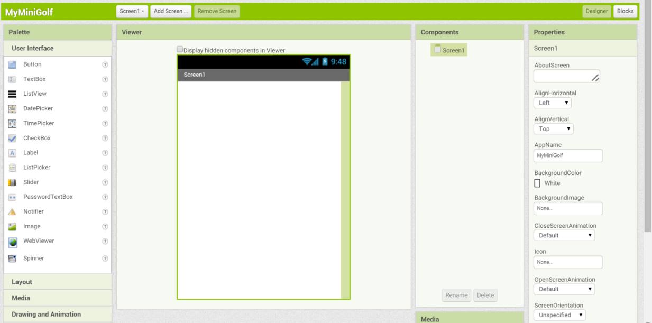

1.3 Design of the user interface
- At the beginning, you can see only ONE Component "Screen1"
- Change the Properties of component "Screen1".
Title | "2X99 Guess Number Game"(2X99 should be your class and class number.)
AlignHorizontal | Center: 3

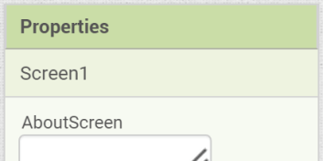
- Place a component “Horizontal Arrangement” into the scree by dragging “Horizontal arrangement” to “Screen 1”
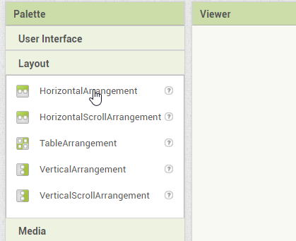 |  | 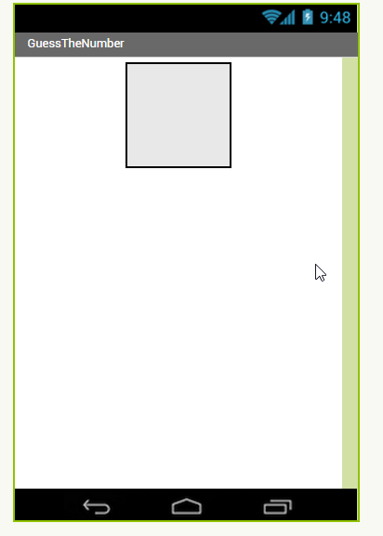

- Place 3 component “Label” into the “Horizontal Arrangement”.
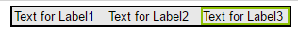
- Change the properties of the “Label”.
Rename:
Label1: Label_Min  Label2: Label_To  Label3: Label_Max | Text: 1  Text: to  Text: 100
FontSize | 20
- Place other components to “Screen 1”
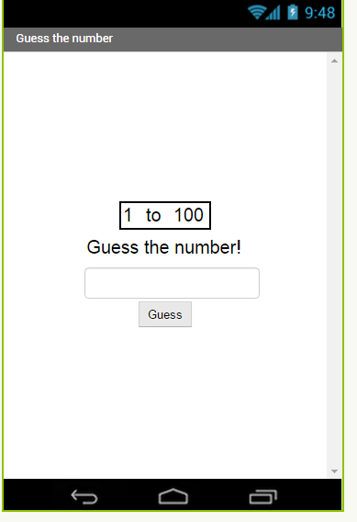
Button:
Button_Guess
TextBox:
TextBox_Guess
Label:
Label_Result

- Change the Properties of components.
Label_Result
FontSize | 20
Text | Guess the number!

Text_Guess
FontSize | 20
Hint | Guess the number

Button_Guess
Text | Guess

1.4 Connect the Android Tablet
- Start the program "AI Companion" in the Android Tablet.
- Choose the function "scan QR code" to scan the QR code on the screen.
 |  | 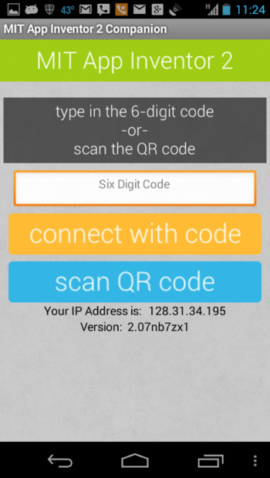
- In the computer, choose "Connect" "AI Companion".
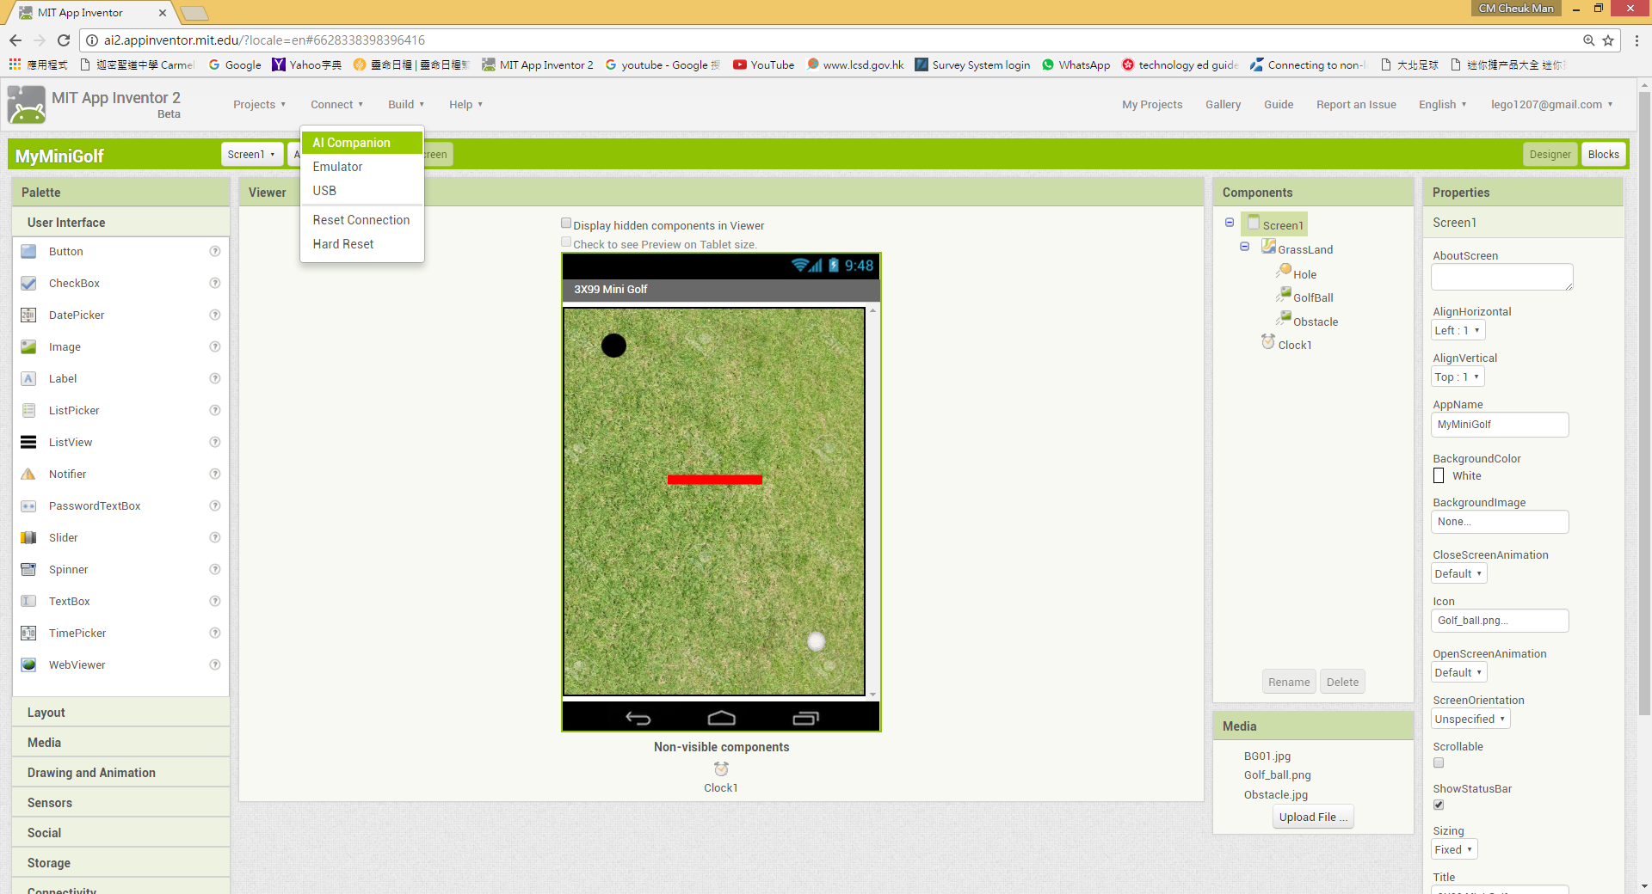
- Use the Android Tablet to scan the QR code or type the code to test the program.
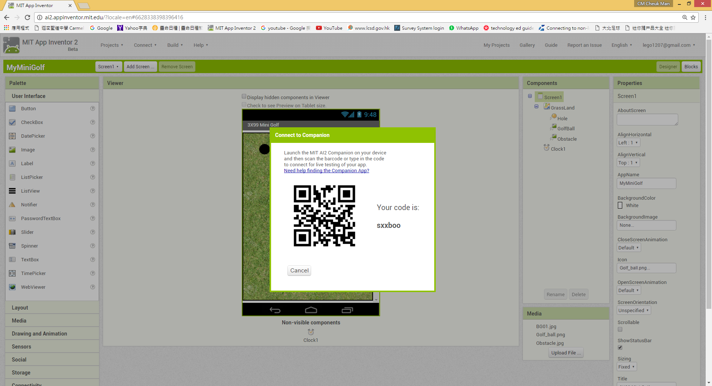

1.5 Program the App
- Starting program the App by clicking "Blocks".
In MIT App Inventor 2, program the App by dragging the "Blocks" together.




1.5.1 Variable for storage
- Select "Variables" in the Blocks. Drag the Blocks "initialize global Name to" to the viewer.
- Click “Name” of the block and change to “Answer”
- Connect the block with a number block with the number from 2 to

The answer of the game is saved with the name “answer” with the following block.
(The block shown below the answer is 49)
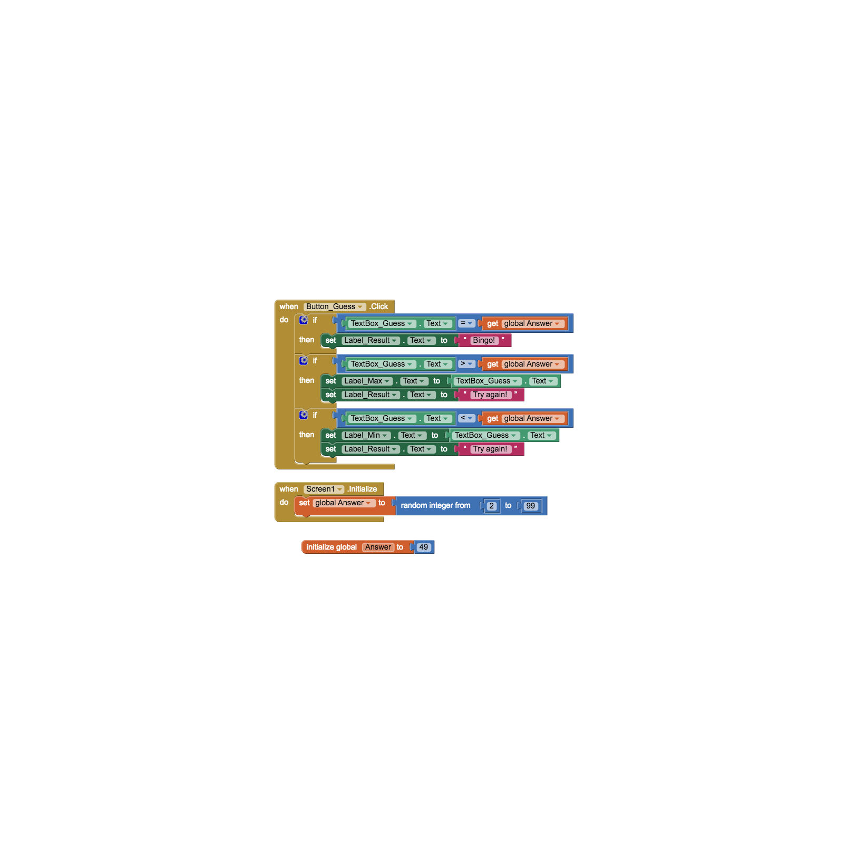

1.5.2 Selection Blocks
- Select "Button_Guess" in the Blocks. Drag the Blocks "when Button_Guess.Click ... do" to the viewer.
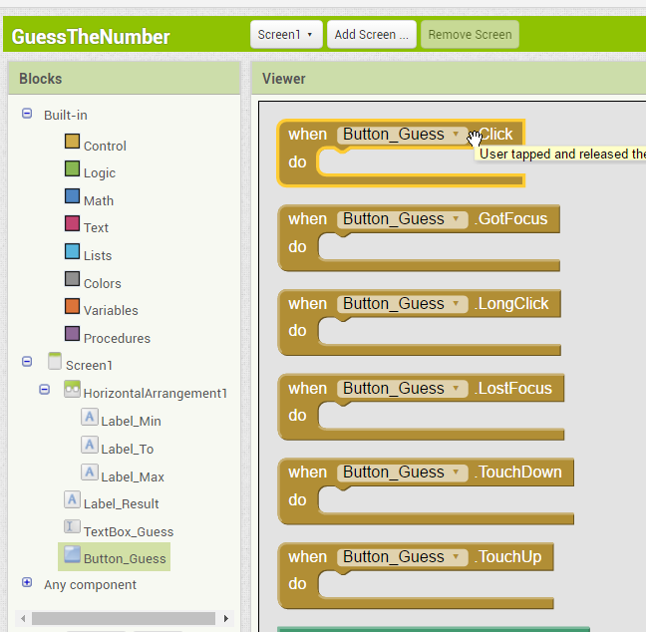

- Select "Control" in the Blocks. Drag the Blocks "If…then " to the viewer.
This block is used to control the block to run under give condition.
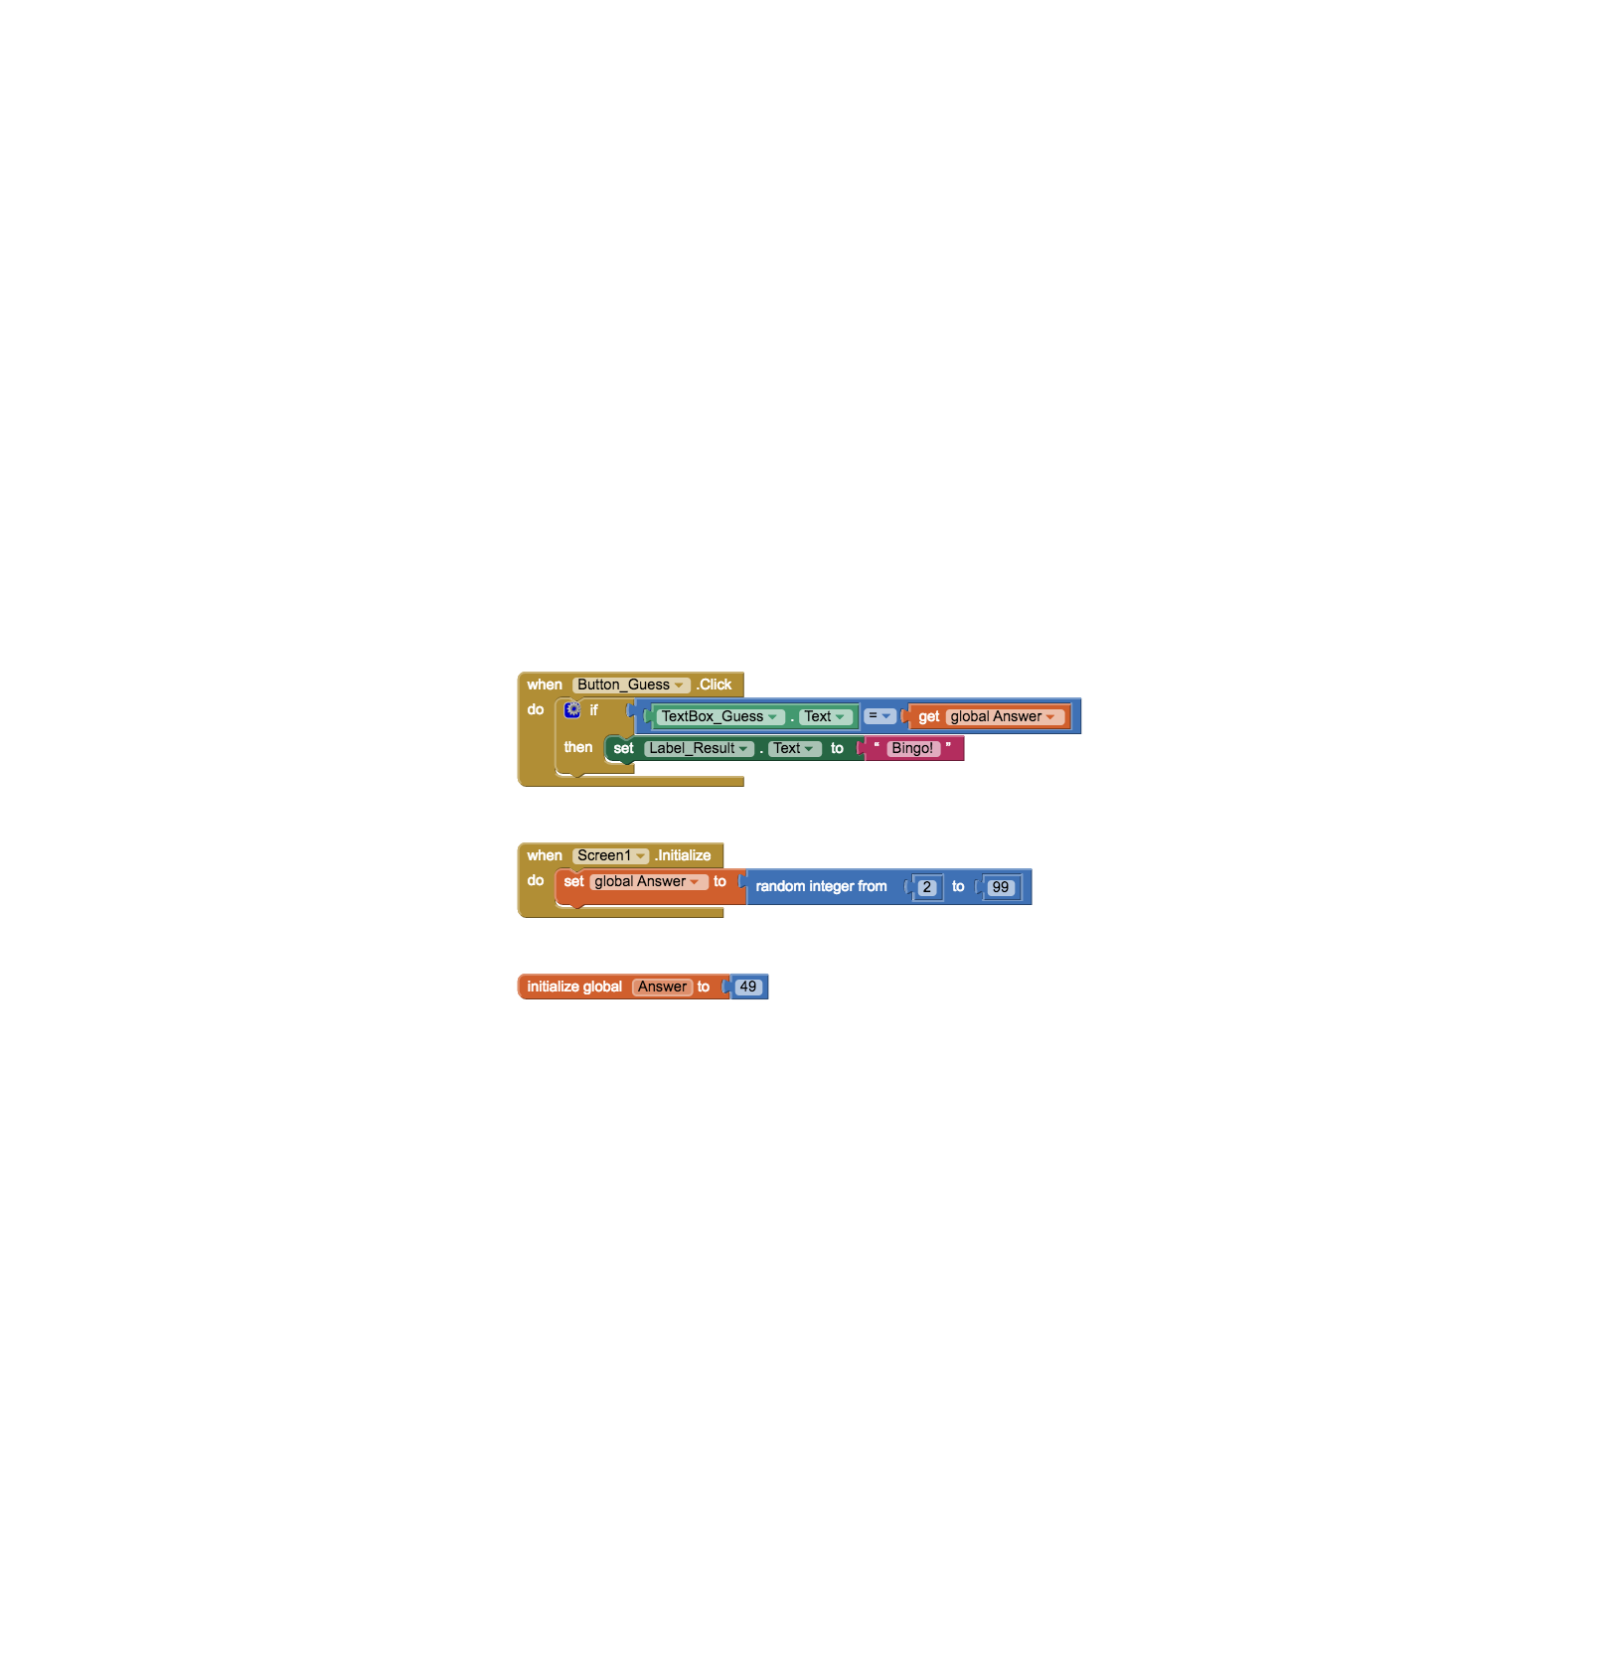
Connect the blocks as shown below.

Condition

1.6 Export the project (.aia)
- Export the project to your computer.
[Projects Exports selected project (.aia) to my computer]
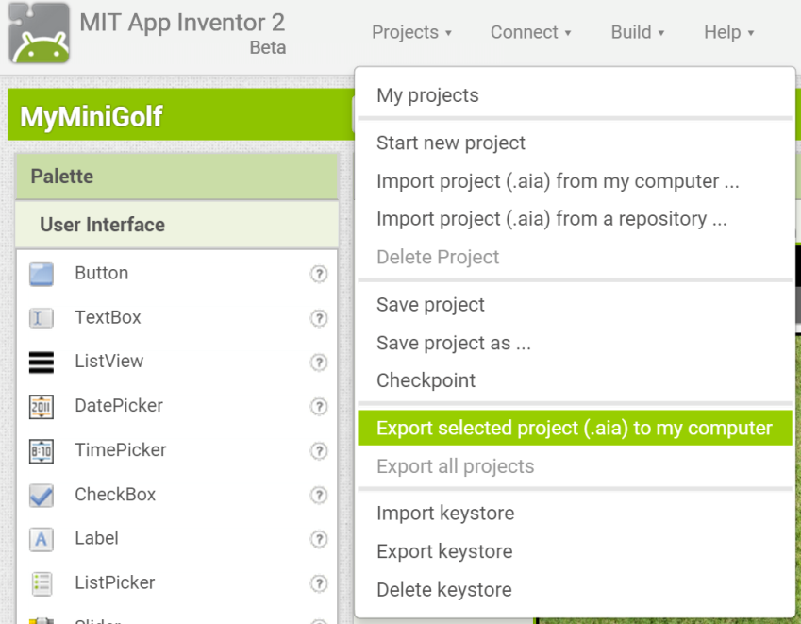

- Save the file "GuessNumber2X99.aia" to your own folder and upload to the Schoology. (2X99 should be your class and class number.)

1.7 Homework
1. Follow the Steps in the notes to build a guess number Game.
2. Test the game to see if it has the following features:
a. The text will change to “Bingo!” if you enter the correct answer.
3. Upload the completed (.aia) file to the Schoology.

Chapter 2 MIT App Inventor 2 – Guess the number (Part 2)

Key Words
Random 隨機 | Initialize 起動

2.1 Program the project by using another Google Account
- If you need to use another Google Account to program your project, you should
  - Export the (.aia) file to your computer first,
  - Login another Google Account,
  - Import Project(.aia) from my Computer.
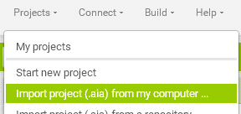

2.2 Install the App into You Android Phone/Tablet
- You can choose "Build" "App (provide QR code for .apk)".
- Install the App to your Android Phone or Tablet by using the QR Code.
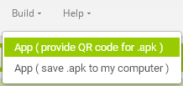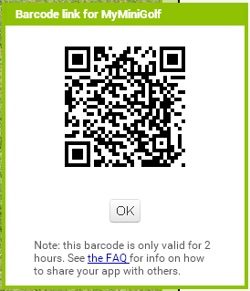

2.3 Change the range statement using if condition.

2.3.1 Using random number as the answer of the game
- Using random number can make the answer of each game different and make the game more fun.
- Select “Math” in the block and pick “random integer from 1 to 100”.
- Change the number 1 to 2 and 100 to 99.
- Select “Screen1” and pick event “When Screen1.Initialize” and “variable” ”Set____to”
- Connect the blocks as show below.


2.3.2 Adding selection block for the range
- If the player does not answer correctly, the range displayed will be smaller so that the next player can get the answer more easily.
- If the guess is larger than the answer, the maximum of the range should be reduced so the range become smaller.

New Range
Original Range

Minimum Answer Guess Maximum

- Select a new if block and setup its condition with “Test_Guess.Text””>” “Get Global Answer”
- Change the Maximum number of the range/Label.
- Change the Label_Result to tell the player to try again

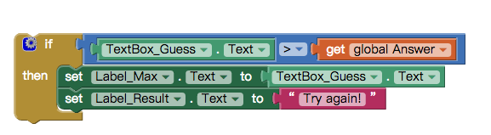
- Add the blocks above to the When Button_Guess.Click Event
- The minimum number is leave for exercise.

2.4 Homework
1. Follow the Steps in the notes to finish the Game.
2. Test the game to see if it has the following features:
a. The Range will change if the answer is not correct.
b. The text will change to “Bingo!” if you enter the correct answer
3. Export and upload the completed (.aia) file to the Schoology.

Chapter 3 MIT App Inventor 2 – Guess the number (Part 3)
Key Words
Clock 計時器 | Non-visible components. 不可見元件

3.1 Adding time limit to the game.
- Select “Sensors” and “Clock” and drag it on to “Screen 1”.
- The Clock will appear in the bottom of “Screen 1” as non-visible components.
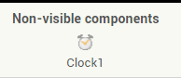
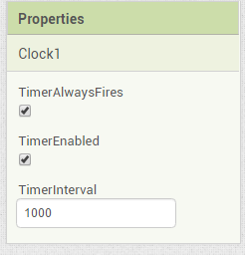 | Timer Enabled: The Clock is “switched on”  TimerInterval: How long is the time is up in 1/1000s  (1000 means = 1 sec.)

- Add one HorizontalArrangement and 2 labels
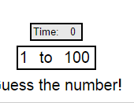
Label 1
Rename | Label_Time
Text | Time :

Label 2
Rename | Label_sec
Text | 0

- Adding block from “Clock1” “when.Clock1.Timer. This is the event which time the time interval is up.
- For each time is up (1 sec), the displayed time should be increased by 1.
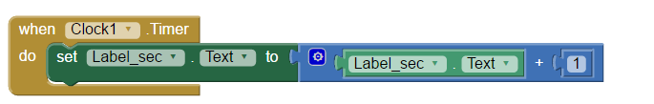
- To stop the timer, use the block “set Clock1.TimerEnabled” and “false”
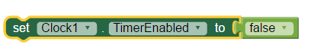

3.2 Homework
1. Follow the Steps in the notes to finish the Game.
2. Test the game to see if it has the following features:
a. The timer starts when the game starts.
b. The timer stops when player answer correctly.
3. Export and upload the completed (.aia) file to the Schoology.

Guess猜測
Range 範圍
User Interface 用戶介面
Component元件
Properties 屬性
Title 標題
Blocks 程式塊
Condition條件
Export 匯出
Random 隨機
Initialize 起動
Clock 計時器
Non-visible components. 不可見元件

